**Name:** Arvind C. Pawar

**Assignment**: ALY-6010 Week 2 Project

**Course Title**: Probability Theory and Intro Stats

**Academic Term**: Fall 2018 2nd Sub Quarter

**Instructor**: Prof. Jamie Warner

**Date**:11/11/2018

We have given a data of 50 projects which are randomly selected by Quality Control Manager of manufacturing company. Each project has it’s unique ID, Quality Score, No. of day’s a project been completed and Cost of the Project. I have applied the Experimental and Theoretical Probability theories on given Data.

**Part 1**

**Introduction:**

There are three occasions, Quality, Speed and Cost. Every occasion has its criteria which each task should fulfil to get considered as a decent venture. Quality of task fulfilled if the quality score is higher than 500, Speed fulfilled if the undertaking took under 13 days for its finishing and for the factor cost fulfilled if the venture cost is under $23400.

* Along these lines, figured the number of projects which has fulfilled the above criteria for every one of the given components. I used COUNTIF Function to count the number of projects with the given condition.

**COUNTIF (range, criteria)**

1. **Count Q =COUNTIF (B2:B51,">500")**
2. **Count S** **=COUNTIF (C2:C51,"<13")**
3. **Count C =COUNTIF (D2:D51,"<234000")**

**Column B represents the data of Quality Score**

**Column C represents the data of Speed**

**Column D represents the data of Cost**

* After getting the count, figured the likelihood of every occasion.

1. P(Q) = Count of Projects which satisfied the Criteria of Quality/ No. of sample points (No. of projects)

**=J2/COUNT($A$2:$A$51)** (**J2** represents the **cell** – **count of projects with satisfied criteria of Quality**)

1. P(S) = Count of Projects which satisfied the Criteria of Speed/ No. of sample points (No. of projects)

**=J3/COUNT($A$2:$A$51) (J3** represents the **cell – count of projects with satisfied criteria of Speed)**

1. P(C) = Count of Projects which satisfied the Criteria of Cost/ No. of sample points (No. of projects)

**=J4/COUNT($A$2:$A$51) (J4** represents the **cell - count of projects with satisfied criteria of Cost)**

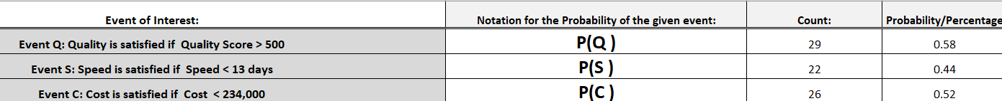

**Analysis:**

From the above outcomes, a Quality Control Manager will become more acquainted with that out of 50 ventures, just 29 ventures have great Quality, and the level of the qualified task is 58%. 28 tasks couldn't complete in an expected time period, and 26 projects were in the financial plan. Among all the factors, Quality is the factor which is higher.

**Conclusion:**

A Manufacturing organization would now be able to search for the reasons in what they lacked which brought about the projects taking additional time and more expense to finish. Now they would be able to focus on Quality, Cost and speed factors and can improve the upcoming projects.

**Part 2**

**Introduction**

* There is a score from 0-7 given to the values of each factor based on the satisfaction of the criteria. In part 2, calculated how many projects have satisfied one criterion, two criteria and all three criteria and how many projects have not satisfied any of the factor based on the specified criteria.
* Following are the criteria and its given scores.

1. If none of the three criteria is satisfied, then a score of zero is given to that project.
2. If only the Quality criterion is satisfied, but none of the other two are satisfied, then a score of 1 is given to that project.
3. If only the Speed criterion is satisfied, but none of the other two are satisfied, then a score of 2 is given to that project.
4. If only the Cost criterion is satisfied, but none of the other two are satisfied, then a score of 3 is given to that project.
5. If Quality and Speed are satisfied, but the Cost is not satisfied, then score = 4.
6. If Quality and Cost are satisfied, but the Speed is not satisfied, then score = 5.
7. If Speed and Cost are satisfied, but the Quality is not satisfied, then score = 6.
8. If all three criteria are satisfied, then the score is 7.

* I calculated the score for quality, speed and cost, by using if statement. I created the formula based on the above criteria. The formula is as following.

=IF(AND(B2>500,C2<13,D2<234000),7,IF(AND(B2>500,C2<13,D2>23400),4,IF(AND(B2>500,C2>13,D2<234000),5,IF(AND(B2>500,C2>13,D2>234000),1,IF(AND(B2<500,C2<13,D2>234000),2,IF(AND(B2<500,C2>=13,D2<234000),3,IF(AND(B2<500,C2>=13,D2>234000),0,IF(AND(B2<500,C2<13,D2<234000),6))))))))

Copied the formula for all other cells.

* After getting the scores of projects with its respective criteria score, calculated the count and probability.

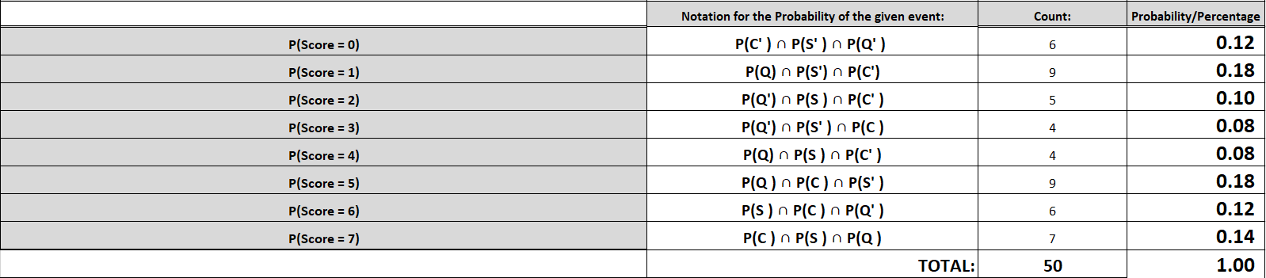

|  |  |  |
| --- | --- | --- |
|  | **Notation for the Probability of the given event:** | **Mathematical Notation** |
| **P(Score = 0)** | **P(C' ) ∩ P(S' ) ∩ P(Q' )** | **P(C') x P(S') x P(Q')** |
| **P(Score = 1)** | **P(Q) ∩ P(S') ∩ P(C')** | **P(Q) x P(S') x P(C')** |
| **P(Score = 2)** | **P(Q') ∩ P(S ) ∩ P(C' )** | **P(Q') x P(S ) x P(C' )** |
| **P(Score = 3)** | **P(Q') ∩ P(S' ) ∩ P(C )** | **P(Q') x P(S' ) x P(C )** |
| **P(Score = 4)** | **P(Q) ∩ P(S ) ∩ P(C' )** | **P(Q) x P(S ) x P(C' )** |
| **P(Score = 5)** | **P(Q ) ∩ P(C ) ∩ P(S' )** | **P(Q ) x P(C ) x P(S' )** |
| **P(Score = 6)** | **P(S ) ∩ P(C ) ∩ P(Q' )** | **P(S ) x P(C ) x P(Q' )** |
| **P(Score = 7)** | **P(C ) ∩ P(S ) ∩ P(Q )** | **P(C ) x P(S ) x P(Q )** |

**Analysis**

Among every one of the projects 12% Projects does not fulfil any of the criteria. We can see that 18% of ventures have fulfilled just Quality criteria. 10% projects could get finished inside the predetermined due date, however, couldn't give expected quality and took more costs. The projects which have quality and finished inside a given period are 8% yet was costly, while there are 8% projects which cost much, however, couldn't give quality and accepting numerous days to finish also. 18% projects fulfilled the Quality and Cost yet couldn't finish inside indicated time. 12% of projects do not fulfil the quality, however, fulfilled the other two criteria. 14% projects fulfilled every one of the criteria.

**Conclusion**

From the above analysis, I can conclude that aside from those 14% undertakings which have fulfilled every one of the criteria, a few projects have high quality, however, took numerous days to finish and costs much. A few projects are finishing on time, however, missing with respect to quality and are expensive. Projects are compromising on components while accomplishing other elements.

**Part 3**

**Vein Diagram:**

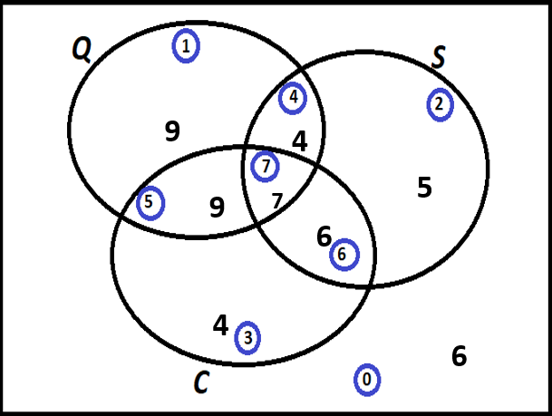

**Introduction**

A Venn chart has been made dependent on the scores apportioned for each occasion and criteria. Utilizing ideas of Conditional Probability, Bayesian Theorem, I have figured the calculated the counts as mentioned above using COUNTIF and COUNTIFS functions and the probabilities of each required variable.

**Analysis**

A Venn Diagram is showing us all the logical relationships between projects. There are total four projects which satisfied the Quality and Speed criteria. Six projects satisfied the Speed and Cost criteria. Nine projects satisfied the Quality and Cost but not satisfied with the speed. 6 projects didn’t satisfy any of the criteria.

**Conclusion**

Using Venn diagram, we can easily understand the relationships between events where they are overlapping with each other. It makes our analyzation easy.

**Part 4**

**Introduction**

**In Part 4 we have given various questions which are asking us to find out the probability**

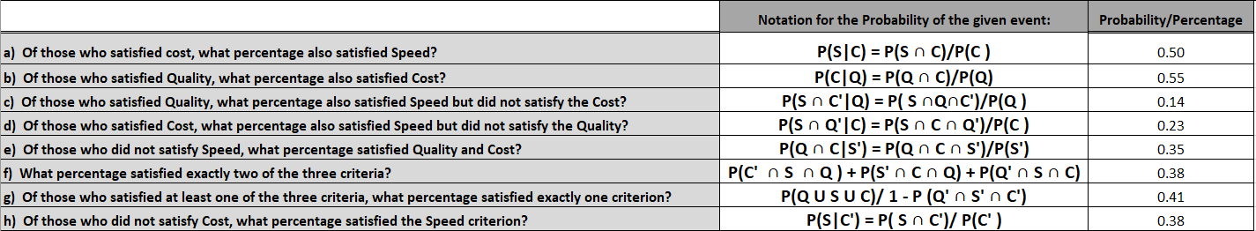

|  |  |  |
| --- | --- | --- |
| **Probabilities** | **Formula** | **Count** |
| **P(Q** ∩ **C)** | COUNTIFS(B2:B51,">500",D2:D51,"<234000") | **16** |
| **P(Q** ∩ **S)** | COUNTIFS(B2:B51,"<500",C2:C51,"<13") | **11** |
| **P(S** ∩ **C)** | COUNTIFS(C2:C51,"<13",D2:D51,"<234000") | **13** |
| **P(Q** ∩ **S** ∩ **C)** | COUNTIFS(B2:B51,">500",C2:C51,"<13",D2:D51,"<234000") | **7** |

**Conclusion**

This project gave me insight and hands on experience how to process organization data and analyze it. According to me by analyzing the data of only 50 projects may not give us appropriate outcomes. But based on the given results quality manager and his/her team can make the decisions and strategies to improve their performance and future projects. Apart from this, by working on this project, I got familiar with COUNTIF and COUNTIFS, IF STATEMENTS and concepts of experimental and theoretical probability.

**References:**

1. Venn diagram. (2018, November 10). Retrieved from <https://en.wikipedia.org/wiki/Venn_diagram>
2. (n.d.). Retrieved from <https://northeastern.blackboard.com/webapps/blackboard/content/listContent.jsp?course_id=_2567921_1&content_id=_19591477_1>
3. IF function. (n.d.). Retrieved from <https://support.office.com/en-us/article/if-function-69aed7c9-4e8a-4755-a9bc-aa8bbff73be2>